Creating/Scheduling a new event
All club events need to be approved and verified by the committee representative, who should consult with relevant experts.
Each trip MUST have an organiser and a leader (they can be the same person). The trip should:
- Have an approved leader for the appropriate grade
  - It is worth consulting with other leaders of more experience for the type of trip e.g. Dale Clarke or Dave Clarke
  - Two assistant leads (of appropriate skills cross over) can lead canal and green flow
- For newly qualified or leaders without large group experience:
  - set the limit of people who can attend the trip (and the experience to be counted as part of that number)
  - set the experience allowed to attend
- Should not conflict with similar trips on the same day
- Should attempt to spread the trips throughout the year instead of clustered in one month
Once all agreed. The following is needed:
- Create the description text to put in the events
- Create a website event
- Create a Facebook event
- Update the annual calendar

Setup the text:
Using the below template and in NOTEPAD (so no formatting), complete:
<Description>
<Constraints>
<Additional Info>
This event is being organised over Facebook – if you don’t use Facebook, please email trips@hinckleycanoeclub.co.uk who will pass your request on to the organiser.

Leader(s): <whoever>
Organiser(s): <whoever>

This trip is only open to club members. On occasions we will (and frequently do) allow other none members to attend, but this is only by prior arrangement.

Where:
- <Description> is a cheerful marketing description
- <Constraints> are any limits put on the trip, examples would include:
  - Numbers limited so first come first served
  - Experience of paddler restricted
  - Kit limitations – e.g. canoe must have air bags; or poles needed
  - Risks to selves and kit – e.g. damage to equipment is possible and is your risk (e.g. canoe pin)
- <Additional Info> includes things like camping or other bits and bobs.
- <Leader> and <organiser> are the names accordingly – the leader MUST have their mug shot on the leaders page
  - NOTE: You can assign a leader later, but the trip can’t go ahead without one
- Facebook waiver: This is only on the website, obviously removed on the FB event
- Bottom waiver: This is generic. Public events worded differently.

Examples:

A touring trip down the River Tame, a very scenic and relaxing paddle.

The trip has a limited number of places and is restricted to Kayaks only. You need to have river touring trip experience already for this trip.

This event is being organised over Facebook – if you don’t use Facebook, please email trips@hinckleycanoeclub.co.uk who will pass your request on to the organiser.

Organiser: Ro Puttergill
Leader(s): Ro Puttergill and Neil Smith

This trip is only open to club members. On occasions we will (and frequently do) allow other non-members to attend, but this is only by prior arrangement.
A pleasant paddle on the Dove, which is only paddler at this time of year. This trip is open to all.

This event is being organised over Facebook – if you don’t use Facebook, please email trips@hinckleycanoeclub.co.uk who will pass your request on to the organiser.

Leader: Dave Clarke

This trip is only open to club members. On occasions we will (and frequently do) allow other none members to attend, but this is only
A Grade 2/3 Trip somewhere within England/Wales. Further details to follow
The trip has limited numbers, so will first come first served. Expectation is that you have experience of paddling Grade 2/3, for example the River Dee is ok. If you aren’t sure, then please contact the leader who will assist you here.
We will be camping over the weekend an Tyn Cornell, details will follow.

This event is being organised over Facebook – if you don’t use Facebook, please email trips@hinckleycanoeclub.co.uk who will pass your request on to the organiser.

Leader: Dale Clarke
Organiser: Michael Ward

This trip is only open to club members. On occasions we will (and frequently do) allow other non-members to attend, but this is only by prior arrangement.
Below is an example for Open to the public:
East Midlands Paddlers is championing a new trail called the Bliss trail that is approximately 900 miles long in a continuous loop throughout England.

As part of this, we’ve agreed to play host to one of these sections and run a trip from the marina at Crick to Foxton Locks, with a possible half way exit at marina at North Kilworth, for a slightly shorter paddle.

This event is being organised over Facebook – if you don’t use Facebook, please email trips@hinckleycanoeclub.co.uk who will pass your request on to the organiser.

More details to follow.

Organiser(s): Richard Matthews
Leader(s): Dave Clarke, Martin Aldridge, Nikki Aldridge

This trip is open to none club members, but will require them to be British Canoeing members.

Create a website event
Log in to the administration web site:
http://www.hinckleycanoeclub.co.uk/wp-admin/index.php
Once logged in, navigate to Events / All Events:
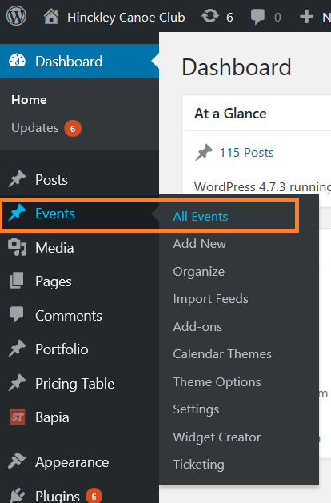
Then click the “Add New” button:
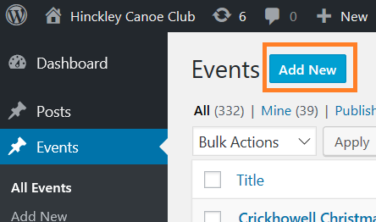
Provide a name. Include the Year/Month at the end in order to prevent duplicating previous events. (the name needs to be unique) e.g.) Scotland White Water Easter Weekend 2017; or Grade 2/3 trip April 2017.
Set the date and times (note that below I’ve set it to “All Day”):
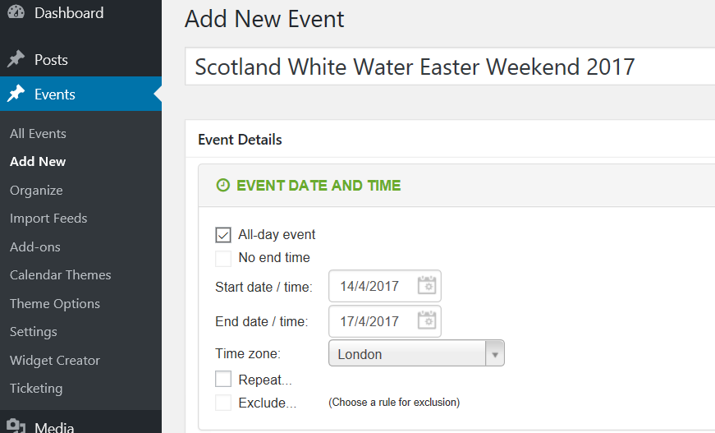

Scroll down and then copy the text from Notepad prepared earlier into the big white box. (IMPORTANT: The tab should be set to TEXT):
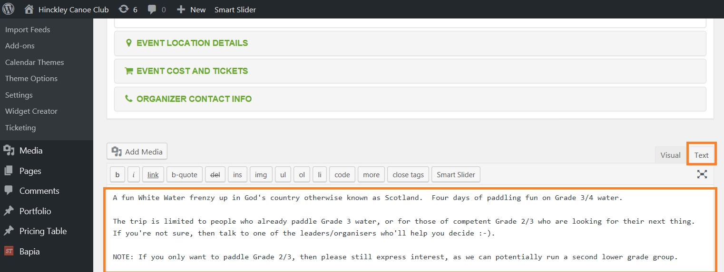
Preview the event:
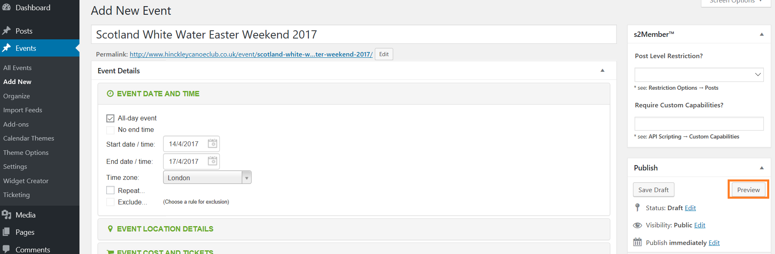
Once happy, publish the event:
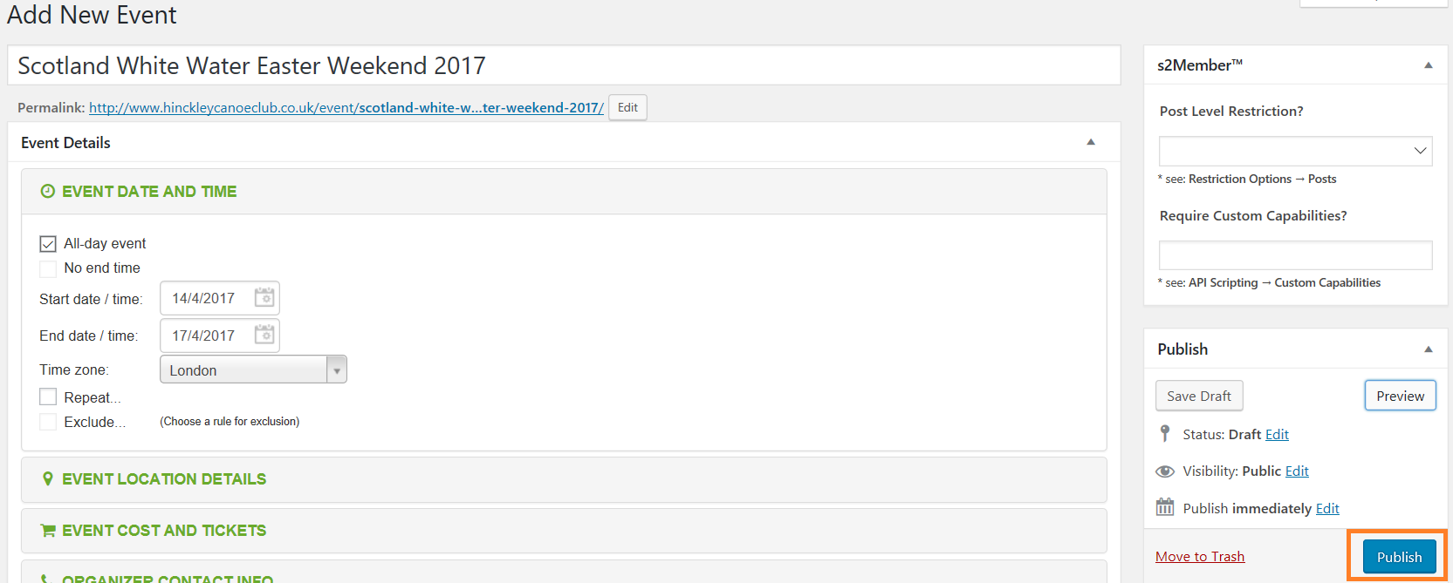

TADA, now to create the Facebook event.

Create the Facebook event
Log in to Facebook as the Hinckley Canoe Club user. You can do this either by using a different browser to the one you usually use, or by using Incognito sessions from your browser. This way it won’t screw up your own facebook!
IMPORTANT: You MUST be a friend of Hinckley Canoe Club (Phil keeps bloody removing me!) Log in as above and then setup the friendship between the accounts!

Once logged in, navigate to the Hinckley Canoe Club website:
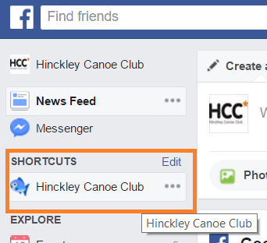

Navigate to Events and click New Event:
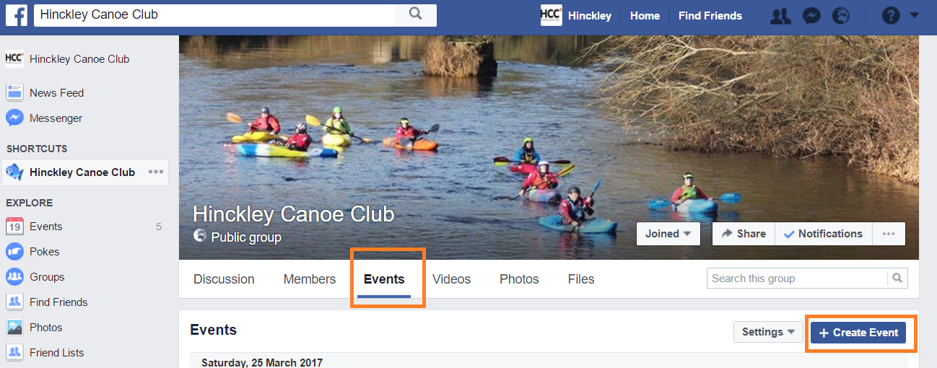

Populate the name and date as per the website event.
Put a location if you wish, and put a photo in there.
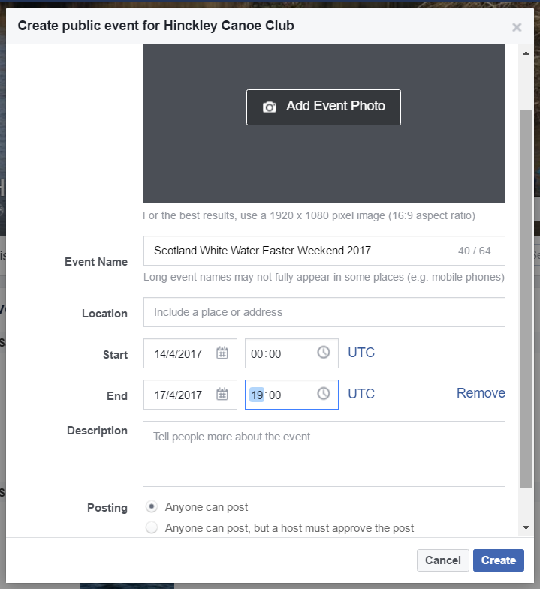
Copy the description in REMOVING the facebook text (as this is facebook ).
Press CREATE.
Edit the event:
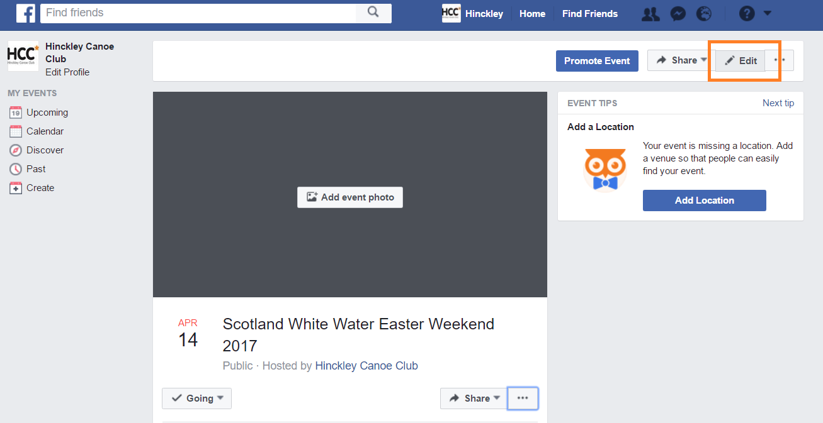

Scroll down and add YOU as a Co-Hosts:
IMPORTANT: You MUST be a friend of Hinckley Canoe Club (phil keeps bloody removing me!)
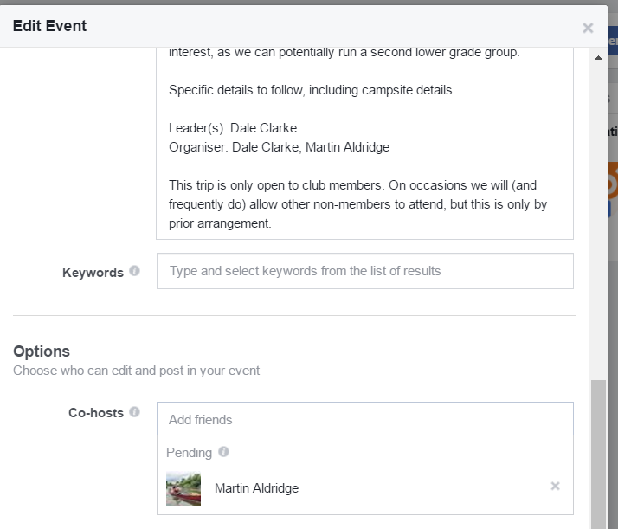

Now in YOUR facebook account, set yourself as going. Edit the event, and then add the leaders and organisers as co-hosts (sometimes you have to refresh the browser several times as Facebook takes a while to update):
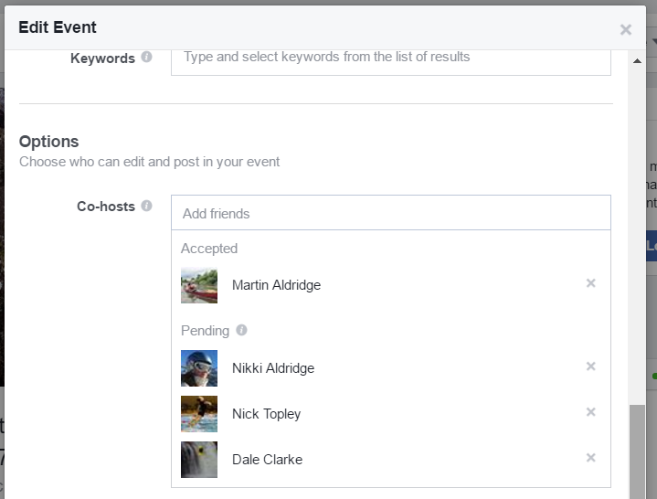
Once they’re going or interested they can update the event accordingly.

Advertise the event on the main HCC facebook page, as this isn’t now done automatically. An example:
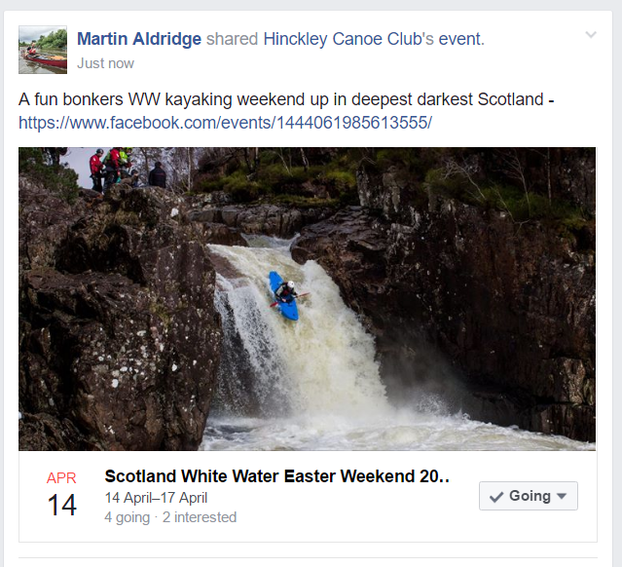

Try and encourage that people communicate via the event and not the posts.

Updating the Annual Organiser
The annual planner is an excellent way for people to see what is happening over the year. You need to :
- Download the latest planner from the website:
  - The Club / Club Documents / Event Calenders / HCC Events Excel Sheet
  - 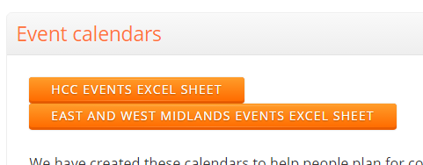
- Change the heading to todays date:
  - 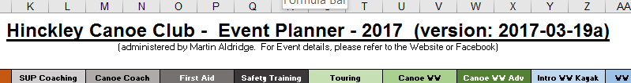
- Update the calendar accordingly
  - I just copy and paste from the legend or other squares
- Ask Rob/Comms bod to upload the latest Excel sheet
- Once done, post on the Facebook page that it’s been updated

