Uploading trip reports
Easy peasy lemon squeezy.
Log in to the administration web site:
http://www.hinckleycanoeclub.co.uk/wp-admin/index.php
Once logged in, navigate to Posts / All Posts:
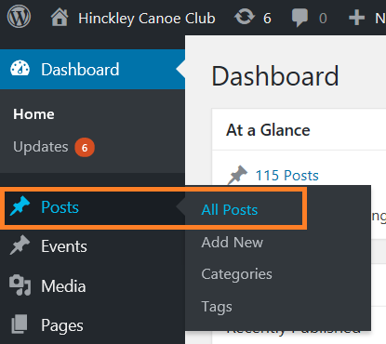
Select “Add New”:
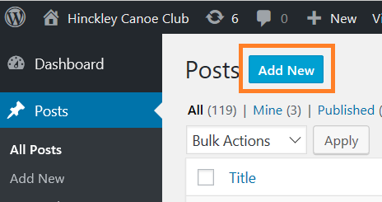
Give you trip report a name, and then copy into the text box. Get as creative as you like, uploading media/images, formatting, etc:
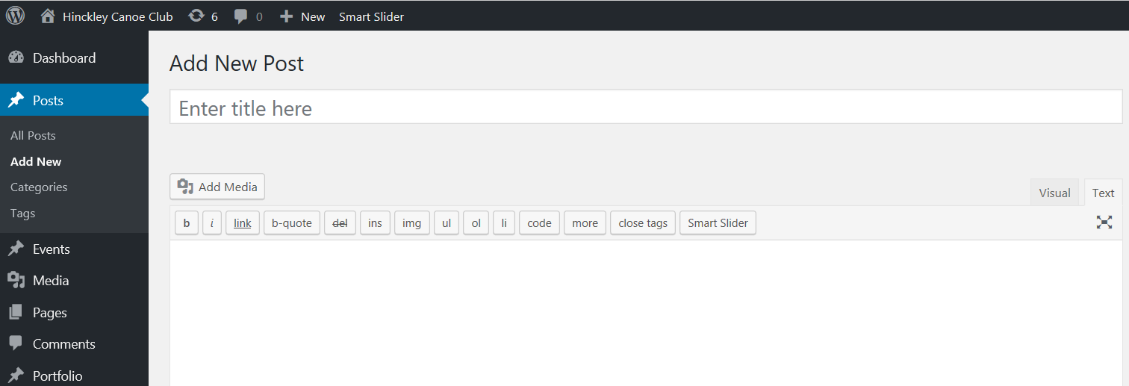
On the Right under categories, select Trip Reports:
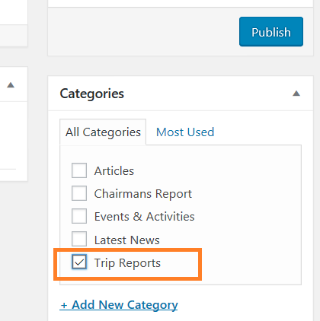

Preview the post first (button on the right):
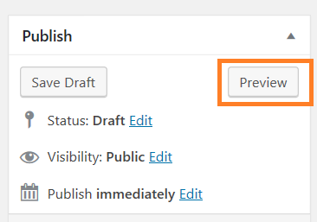
Then Publish the post (button on the right):
